Voting Intentions and Donations

Mark Reardon, 11/7/18

# Overview

A new My Momentum URL has been created that will record a NationBuilder signup’s voting intention for a vote, set appropriate tags in NationBuilder and redirect to a donation page with the form pre-filled with the signup’s details (which will be passed on to Paypal).

Use this in a NationBuilder email blast and create buttons with URLs that correspond to the choices available for the vote.

# 2018 NEC elections

## Choices and tags

|  |  |  |
| --- | --- | --- |
| **Choice** | **Meaning** | **Tags** |
| 1 | Pledge – all 9 | NEC18, LPM18NEC, NEC18_Pledge, NEC18_Email |
| 2 | Voted – all 9 | NEC18, LPM18NEC, NEC18_Vote, NEC18_Email |
| 3 | Backing different candidates | NEC18, LPM18NEC, NEC18_Against, NEC18_Email |
| 4 | Not a Labour member | NEC18, LPN18NEC, NEC18_Email |

## URLs to embed in emails (just email, first and last names for now)

### Choice 1: Pledge – all 9

https://my.peoplesmomentum.com/voting_intentions?vote=1&choice=1&email={{ recipient.email }}&donation_first_name={{ recipient.first_name }}&donation_last_name={{ recipient.last_name }}

### Choice 2: Voted – all 9

https://my.peoplesmomentum.com/voting_intentions?vote=1&choice=2&email={{ recipient.email }}&donation_first_name={{ recipient.first_name }}&donation_last_name={{ recipient.last_name }}

### Choice 3: Backing different candidates

https://my.peoplesmomentum.com/voting_intentions?vote=1&choice=3&email={{ recipient.email }}&donation_first_name={{ recipient.first_name }}&donation_last_name={{ recipient.last_name }}

### Choice 4: Not a Labour member

https://my.peoplesmomentum.com/voting_intentions?vote=1&choice=4&email={{ recipient.email }}&donation_first_name={{ recipient.first_name }}&donation_last_name={{ recipient.last_name }}

# URL

<https://my.peoplesmomentum.com/voting_intentions>

## Mandatory parameters

|  |  |  |
| --- | --- | --- |
| **Name** | **Example value** | **Notes** |
| vote | 1 | Use this value for the 2018 NEC elections |
| choice | 2 |  |
| email | bob@example.com | Use an address in the NB database for testing but remove the tags when done |

## Optional parameters

*To see the other country codes right-click on the country dropdown menu on the donation page and choose ‘Inspect element’*

|  |  |
| --- | --- |
| **Name** | **Example value** |
| donation_first_name | Bob |
| donation_last_name | Smith |
| donation_billing_address_country_code | GB |
| donation_billing_address_address1 | Floor 3 Room C303 |
| donation_billing_address_address2 | Cannon Wharf Pell Street |
| donation_billing_address_address3 | Surrey Quays |
| donation_billing_address_city | London |
| donation_billing_address_zip | SE8 5EN |
| donation_billing_address_phone_number | 07111 111 111 |

# Example and results

*Testing notes – progressing from the final step of the donation page to Paypal will update the name, home phone number and billing address in NationBuilder that corresponds to the email used!*

## URL

https://my.peoplesmomentum.com/voting_intentions?vote=1&choice=2&email=bob@example.com&donation_first_name=Bob&donation_last_name=Smith&donation_billing_address_country_code=GB&donation_billing_address_address1=Floor%203%20Room%20C303&dondonat_billing_address_address2=Cannon%20Wharf%20Pell%20Street%20&donation_billing_address_address3=Surrey%20Quays%20&donation_billing_address_city=London&donatiod_billing_address_zip=SE8%205EN&donation_billing_address_phone_number=07111%20120%20111

## Redirects to

https://momentum.nationbuilder.com/donate2?donation_first_name=Bob&donation_last_name=Smith&donation_billing_address_country_code=GB&donation_billing_address_addradd1=Floor%203%20Room%20C303&donation_billing_address_address2=Cannon%20Wharf%20Pell%20Street%20&donation_billing_address_address3=Surrey%20Quays%20&donatiod_billing_address_city=London&donation_billing_address_zip=SE8%205EN&donation_emaie=bob@example.com&donation_billing_address_phone_number=07111%20111%20111

## Screenshot

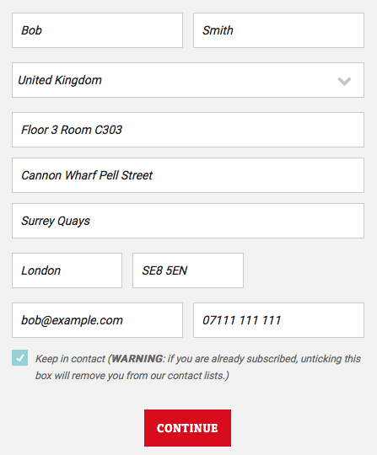

## Tags set

